13+ SCHOLARSHIP EXAMINATION 2017

CHEMISTRY

TIME ALLOWED: 30 minutes

The marks available for each question are printed in brackets.

- Read all the information carefully before you start to answer

- Write your answers in the spaces provided

Name: …………………………………………………………………………

Current school: …………………………………………………………………………

CHEMISTRY

1) | Skiing is one of the most popular winter sports but depends entirely on good snowfall. Snow is formed when water vapour in the air freezes before it can turn to water. This happens when the temperature in the clouds is very cold. Snowflakes are made up of crystals of ice that form around small particles of dirt in the air.
a) | Suggest a temperature the clouds would need to be in order for snow to form. Explain your answer.  ………………………………………………………………………………………  ………………………………………………………………………………………  ………………………………………………………………………………………  (2 marks)
b) | How would the movement and arrangement of molecules in the water you drink differ from that in snow?  ………………………………………………………………………………………  ………………………………………………………………………………………  ………………………………………………………………………………………  ………………………………………………………………………………………  (2 marks)
c) | Water forms from many different chemical reactions. One of these is the combustion of hydrogen. Write a word equation for this reaction.  ………………………………………………………………………………………  ………………………………………………………………………………………  (1 mark)
d) | When universal indicator is added to snow it turns yellow.
i) | What does this tell you about the pH of snow?  ………………………………………………………………………………………  (2 marks)
ii) | Explain how this could have happened to the snow.  ………………………………………………………………………………………  ………………………………………………………………………………………  ………………………………………………………………………………………  (2 marks)
e) | Emma thinks that eating snow is safe because it is only made up of pure water. Describe an experiment to prove that it is, in fact, a mixture of dirt, water and salts. Diagrams may be used to illustrate your method.  ………………………………………………………………………………………  ………………………………………………………………………………………  ………………………………………………………………………………………  ………………………………………………………………………………………  ………………………………………………………………………………………  ………………………………………………………………………………………  ………………………………………………………………………………………  ………………………………………………………………………………………  (5 marks)
 | [Total for Question 1 = 14 marks]
2) | In Chemistry, chromatography can be used to tell whether a reaction is finished in a similar method to identifying colourings in coloured sweets. In this example the reaction can be simplified to:  A + B C  Caroline had done the reaction before, so she had a pure sample of one of the starting materials, A, a pure sample of the product, C, and she took a sample of the reaction as it was going and recorded the following diagram:  Reaction mixture  Pencil line denoting how far the solvent had risen  Solvent  Starting material - A  Product - C
a) | Has the reaction finished? Give a reason for your answer.  ………………………………………………………………………………………  ………………………………………………………………………………………  (2 marks)
b) | Suggest what the blue spot might be (tick all that apply).  - Starting material A  - Starting material B  - Product C  - A by-product of the reaction
 | [Question continues on the next page]
c) | The Rf value can be calculated by dividing the distance a spot has moved from the cross, by the distance the solvent has moved.  $$Rf=\frac{Distance spot has travelled}{Distance solvent has travelled}$$  Calculate the Rf value for the red spot.  (2 marks)
d) | Suggest why this value may not be very accurate.  ………………………………………………………………………………………  ………………………………………………………………………………………  (1 mark)
e) | Why should the lines be drawn with pencil rather than pen?  ………………………………………………………………………………………  ………………………………………………………………………………………  (1 mark)
f) | Other than water, suggest a solvent that could be used.  ………………………………………………………………………………………  ………………………………………………………………………………………  (1 mark)
 | [Total for Question 2 = 9 marks]
3) | Venn diagrams can be used to show the relationship between different groups. A student decided to draw a Venn diagram which linked elements, atoms, compounds, mixtures and molecules.  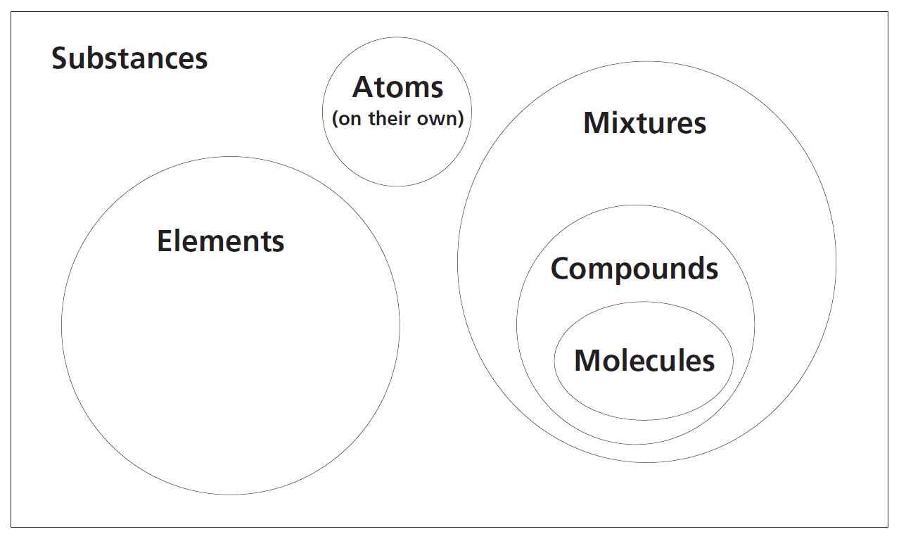  (Reference: RSC Chemistry for the Gifted & Talented)
a) | List three mistakes the student has made when constructing this Venn diagram.  ………………………………………………………………………………………  ………………………………………………………………………………………  ………………………………………………………………………………………  ………………………………………………………………………………………  ………………………………………………………………………………………  ………………………………………………………………………………………  (3 marks)
b) | Draw your own Venn diagram below that links molecules, compounds and elements only.  (3 marks)
c) | Give the number of atoms and the number of elements in sulphuric acid, H₂SO₄.  ………………………………………………………………………………………  ………………………………………………………………………………………  (2 marks)
d) | Which of the following words can be used to describe CO₂? (Tick all that apply)  - An atom  - A molecule  - A compound  - A mixture
 | [Total for Question 3 = 10 marks]
4) | A company Alpha Solutions invented a new synthetic material called, Astro-Lite. They want to use Astro-Lite to insulate space shuttles. The research department at Alpha Solutions tested Astro-lite to see how well it insulated a beaker of hot water, compared to three other materials as shown below:  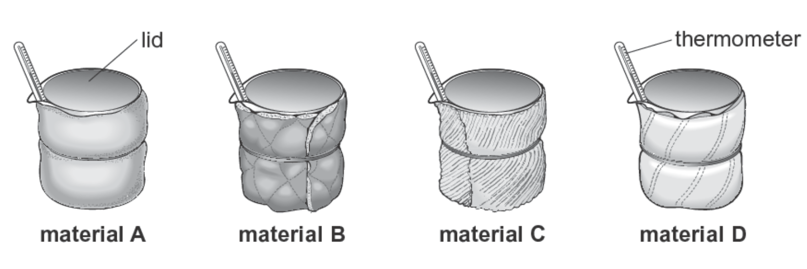  They wrapped each beaker in a different material, then recorded the temperature at the start and 20 minutes later.
a)  (i) | Identify the independent variable for the experiment.  ………………………………………………………………………………………  (1 mark)
(ii) | Identify the dependent variable for the experiment.  ………………………………………………………………………………………  (1 mark)  [Question continues on the next page]
b) | The results for the experiment are shown below:  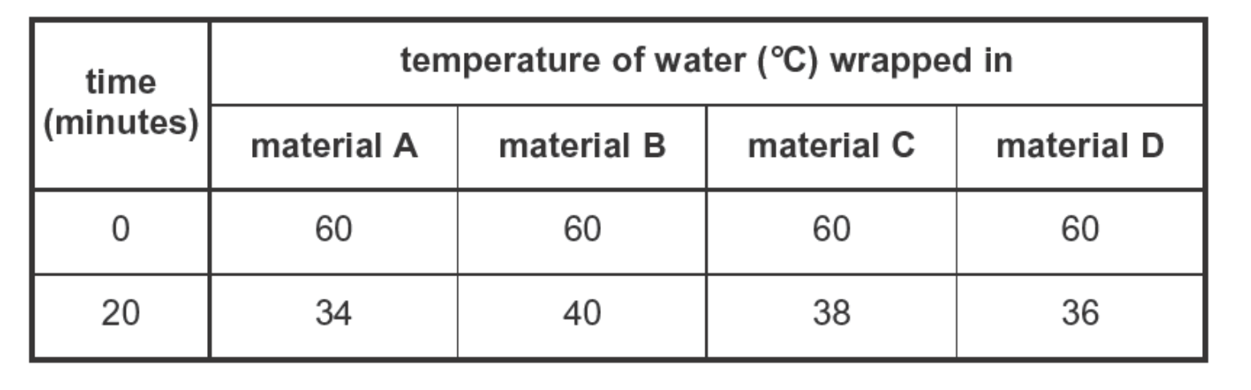  (2009 SATS paper)
i) | The Research Department said that Astro-Lite was the best insulating material. Which material is Astro-lite? Use the information above to help you. Explain your choice.  ………………………………………………………………………………………  ………………………………………………………………………………………  ………………………………………………………………………………………  (2 marks)
c) | The research department made a model of a rocket using each of the four materials that they tested.  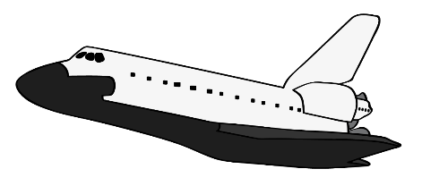  A person tested each of the four rockets by cooling a room using liquid nitrogen. He measured the temperature inside each rocket after 30 minutes.  Provide two other variables that should be controlled to make this a fair test.  ………………………………………………………………………………………  ………………………………………………………………………………………  (2 marks)
d) | Suggest one advantage of using a temperature sensor and a data logger instead of a thermometer in this experiment.  ………………………………………………………………………………………  ………………………………………………………………………………………  (1 mark)
 | [Total for Question 4 = 7 marks]

