

13+ SCHOLARSHIP EXAMINATION 2017

HISTORY

TIME ALLOWED: 70 minutes

TOTAL MARKS: 60

This paper is divided into two sections: Section A and Section B

* **You should answer ALL the questions in Section A and ONE   
  from Section B**
* **Make sure you write all your answers in full sentences**

**Section A: Evidence Question**

*Read the information below, all the sources and then answer all the questions. You should spend 40 minutes on this section.*

This question is about President Franklin Roosevelt’s response to the problems created in the USA by the Great Depression. The Great Depression began in 1929 and led to millions of people losing their jobs and becoming unemployed. Franklin Roosevelt won the 1932 Presidential election promising a ‘New Deal’ for the American people – he was going to do all he could to get Americans back to work and rescue the economy. When he became President in January 1933, he created a range of different agencies, which were responsible for setting up job creation schemes.

[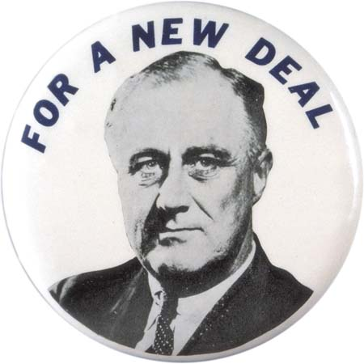](https://www.google.co.uk/url?sa=i&rct=j&q=&esrc=s&source=images&cd=&cad=rja&uact=8&ved=0ahUKEwi0xPWPh5fSAhXIxRQKHSnDBcAQjRwIBw&url=https://www.britannica.com/event/New-Deal&bvm=bv.147448319,d.d24&psig=AFQjCNG6ul0HRFFs0IK1DKZw8tp2hBPp0g&ust=1487418267264580)

**SOURCE A: From a school history textbook, published in 1986**

In November 1933, Roosevelt set up a new agency called the Civil Works Administration (CWA) and within two months it had found work for four million people. The workers built airports, roads, schools and public toilets. Thousands of workers in the CWA were paid to sweep up leaves. Unemployed actors were hired to give free shows. Some people were hired to frighten away pigeons from public buildings.

**SOURCE B: A photograph of Civilian Conservation Corps workers employed on drainage construction in 1933**

[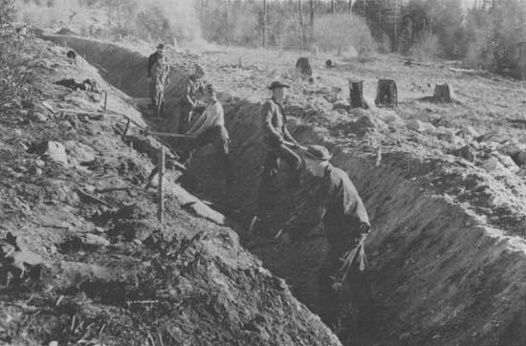](http://www.google.co.uk/url?sa=i&rct=j&q=&esrc=s&source=images&cd=&cad=rja&uact=8&ved=0ahUKEwivnYbq8ZbSAhXCOxoKHSLhA1gQjRwIBw&url=http://www.foresthistory.org/ASPNET/Publications/region/1/history/chap6.htm&bvm=bv.147448319,d.ZGg&psig=AFQjCNFoTRToljsj10z2Ktn4qRH1pvF-Jg&ust=1487412532588896)

**SOURCE C: From a school history textbook, published in 1966.**

The Works Progress Administration (WPA) spent more than $11 billion on 1.5 million projects. WPA workers built more than 2,500 hospitals and 13,000 playgrounds. But some of the WPA projects were attacked for not creating proper jobs – one job cost $12,000 to replace some street signs and another cost $78,000 to repair a ditch. Some people said the jobs were just “make work” assignments to keep people busy but not actually doing work that was needed.

**SOURCE D: From an interview in 1970 with a US citizen who had worked for the Civilian Conservation Corps.**

I was at the Civilian Conservation Corps (CCC) for six months, I came home for fifteen months, looked around for work, and I found that I couldn’t make $30 a month so I enlisted back in the CCC and went to Michigan [a state of the USA]. I spent another six months there planting trees and building forests. Then I left again. But still no money was to be made. So back into the CCC. From there I went to the city of Boise, in Idaho, and was attached to the forest rangers. Spent four months fighting forest fires.

**SOURCE E: A painting, by the US artist William Gropper, completed in 1939, entitled *Construction of the Dam*. Gropper was employed as an artist by the Works Progress Administration.**

[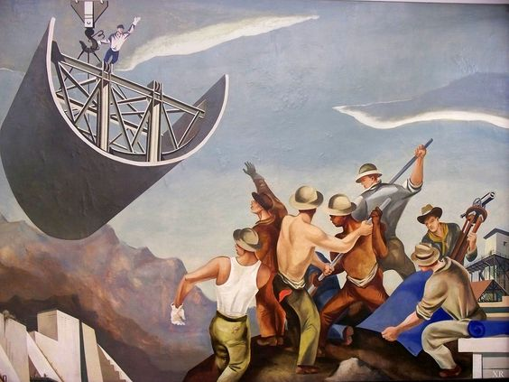](https://www.google.co.uk/url?sa=i&rct=j&q=&esrc=s&source=images&cd=&cad=rja&uact=8&ved=0ahUKEwj8lOqD8pbSAhVCnBoKHaqeCGYQjRwIBw&url=https://www.pinterest.com/pin/57139488994875596/&psig=AFQjCNGROEtF5sZ1brAXEseofjNVHnnjxg&ust=1487412640138783)

**SOURCE F: A graph from a school history textbook showing unemployment figures in the USA in the years 1929-41.**



**Questions**

1. **Study Source A**

What can you learn from Source A about Roosevelt’s attempts to create jobs when he became President of the USA? **(4)**

1. **Study Sources A, B and C**

How far does Source C support the evidence of Sources A and B about job creation schemes? Explain your answer. **(6)**

1. **Study Sources D and E**

How useful are Sources D and E as evidence about the New Deal? Explain your answer. **(8)**

1. **Study all the sources**

‘By 1941, there were still six million people unemployed in the USA. Roosevelt’s New Deal had therefore failed.’

Use the sources to explain how far you agree with this view. **(12)**

**Sub-total: 30 marks**

**Section B: Essay Section**

*You should choose ONE essay from this list. You should spend 30 minutes on this section.*

1. To what extent does Alfred the Great deserve to be called ‘the Great’?
2. Why has there been conflict between monarchs and the church in England? Explain with reference to at least **one** monarch you have studied from 1066-1547.
3. How serious was the threat posed to the Tudors by EITHER Wyatt’s Rebellion (1554) OR the Northern Rebellion (1569)?
4. Assess the impact of the English Civil War (1642-46) on England.
5. ‘The Jacobites posed little real threat to the Hanoverians.’ Explain how far you agree with this view.
6. Why do wars happen? Explain your answer with reference to at least **two** wars you have studied.
7. Using any 50-100 year period you have studied, assess how far the lives of working class people changed.

**Sub-total: 30 marks**

**Total for the Paper: 60 marks**