13+ SCHOLARSHIP EXAMINATION 2017

PHYSICS

TIME ALLOWED: 30 minutes

Calculators may be used.

The marks available for each question are printed in brackets.

- Read all the information carefully before you start to answer

- Write your answers in the spaces provided

Name: …………………………………………………………………………

Current school: …………………………………………………………………………

PHYSICS

1 | The diagram shows a ray of light from a distant star incident on a plane mirror. Complete the diagram to show how the ray of light reflects from the mirror. | (2)
 | 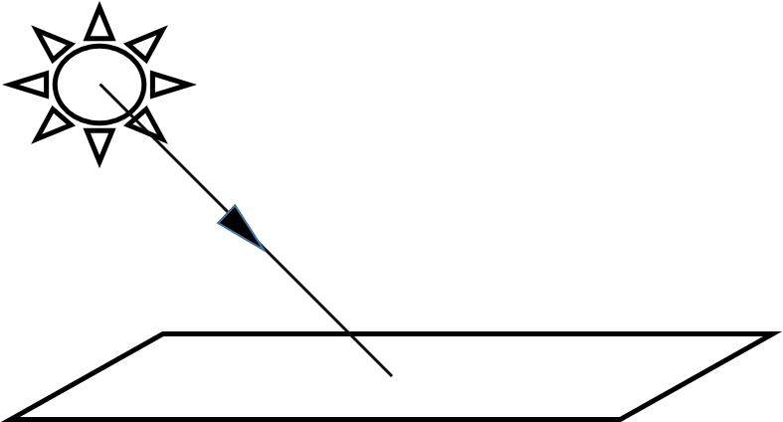
2 | The moon is a non-luminous body. Explain how we are still able to see it from earth. | (2)
……………………………………………………………………………………………………………………………………….
……………………………………………………………………………………………………………………………………….
……………………………………………………………………………………………………………………………………….
……………………………………………………………………………………………………………………………………….

3 | A pulse of laser light is directed from the earth to a reflector on the surface of the moon, left by Apollo Mission astronauts. The reflector directs the pulse of light back to its point of origin on earth where it can be detected as it returns. The pulse of light returns to earth 2.6s after it is transmitted.
a) | Explain the reason for the 2.6s time delay. | (2)
……………………………………………………………………………………………………………………………………….
……………………………………………………………………………………………………………………………………….
……………………………………………………………………………………………………………………………………….
……………………………………………………………………………………………………………………………………….

b) | Calculate how long it takes for the pulse of laser light to travel from the earth to the moon. Show your working carefully. | (1)
……………………………………………………………………………………………………………………………………….
……………………………………………………………………………………………………………………………………….

c) | If light travels through a vacuum at 300, 000km/s calculate the distance from the earth to the moon. Show your working carefully. | (3)
……………………………………………………………………………………………………………………………………….
……………………………………………………………………………………………………………………………………….
……………………………………………………………………………………………………………………………………….
……………………………………………………………………………………………………………………………………….
……………………………………………………………………………………………………………………………………….

d) | Some animals, like bats, use pulses of sound to locate the position of their prey and other objects. Give one reason why using a pulse of sound to find the distance from earth to the moon would be inappropriate. | (1)
……………………………………………………………………………………………………………………………………….
……………………………………………………………………………………………………………………………………….

4 | An astronaut took a navigational compass to the moon. The astronaut inferred from the way his compass behaved that the moon had a very weak magnetic field, and that it did not have magnetic North and South Poles like the earth.
a) | What do you understand by the term magnetic field? | (2)
……………………………………………………………………………………………………………………………………….
……………………………………………………………………………………………………………………………………….
……………………………………………………………………………………………………………………………………….
……………………………………………………………………………………………………………………………………….

b) | Describe how you think the astronaut’s compass might have behaved on the moon. | (1)
……………………………………………………………………………………………………………………………………….
……………………………………………………………………………………………………………………………………….

c) | The astronaut placed four smaller navigational compasses close to each other on the surface of the moon as shown below. The direction pointed by the needles of two of them are shown. Draw arrows on the diagram below to represent the direction pointed by the needles of the other two compasses. | (2)
4 | The ancient Greeks developed the idea that matter is made up of small, invisible particles called atoms. The model we have of the atom today is of a massive, positively charged nucleus surrounded by orbiting electrons (shown below). The diameter of an atom is only around 10⁻¹⁰m or 0.000 000 1mm.
a) | Explain why the model of the atom shown in the diagram above is sometimes called the planetary model. | (2)
……………………………………………………………………………………………………………………………………….
……………………………………………………………………………………………………………………………………….
……………………………………………………………………………………………………………………………………….
……………………………………………………………………………………………………………………………………….
b) | What do physicists understand by the term massive? | (1)
……………………………………………………………………………………………………………………………………….
……………………………………………………………………………………………………………………………………….
c) | A pin head has a diameter of 2mm. Using information given earlier in this question calculate the number of atoms that could fit across the diameter of the pin. | (2)
……………………………………………………………………………………………………………………………………….
……………………………………………………………………………………………………………………………………….
……………………………………………………………………………………………………………………………………….
……………………………………………………………………………………………………………………………………….
5a) | In the space below draw a diagram to describe a simple (single cell) electric circuit that you might set up to turn a lamp and buzzer on and off independently. You should use the appropriate circuit symbols. Circuit components normally available in a school science laboratory are available to you. | (3)
b) | On your circuit diagram you should label clearly with an “X” a component that transfers chemical to electrical energy. | (1)
c) | You are asked by your teacher to give a piece of advice to a student who has not used an ammeter before and wants to include one in a circuit they are setting up. State one piece of advice you would give about how they should include the ammeter in the circuit. | (1)
……………………………………………………………………………………………………………………………………….
……………………………………………………………………………………………………………………………………….
6 | Oil can be used to manufacture petrol to fuel motor cars. Oil is a non-renewable source of energy.
a) | What do you understand by a renewable source of energy? Give an example. | (2)
……………………………………………………………………………………………………………………………………….
……………………………………………………………………………………………………………………………………….
……………………………………………………………………………………………………………………………………….
……………………………………………………………………………………………………………………………………….
b) | Some electricity companies will reduce the price of electrical energy to customers if they use it at night when customer demand for it is low, yet petrol stations still charge the same price for fuel day or night. Even though the demand for petrol at night is also less than in the daytime, why is electricity sold more cheaply at night than it is during the day? | (2)
……………………………………………………………………………………………………………………………………….
……………………………………………………………………………………………………………………………………….
……………………………………………………………………………………………………………………………………….
……………………………………………………………………………………………………………………………………….
c) | Energy from power stations in the form of electrical energy is very useful compared to other forms. Suggest a reason why. | (1)
……………………………………………………………………………………………………………………………………….
……………………………………………………………………………………………………………………………………….
……………………………………………………………………………………………………………………………………….
……………………………………………………………………………………………………………………………………….

